**

|  |
| --- |
| ASE Lab 3 Report |
| UI Mashup  Nutritionix API  Text to Speech API |
| *February 22, 2019*  *Authored by:  Dharani Muli (Class ID: 18), Chakra Pavan Kumar Kota (Class ID :13)* |

Introduction

Objectives

1. Build Registration and Login pages using local storage
2. Integrate with Nutritionix and text to speech API by creating own keys
3. Should build single page web application with webservices mashup

Features

Below are the features that we implemented as part of this application:

1. Registration with form validation.
2. Login with validation.
3. Use can view the Calories and Weight (in grams) information of the food item searched.
4. Our “text to speech” service will read out the information provided visible in the search screen.

Design/Implementation

We have followed below steps to successfully complete this lab assignment:

**Step -1:** We make sure all the pre-requisites are ready before start of the project and below are the technologies/languages used:

1. WebStorm IDE
2. Node
3. Npm
4. Ionic : npm install -g ionic
5. Cordova: npm install -g cordova
6. Angular 7
7. TypeScript
8. Bootstrap

**Step-2:** We have created a new project and 3 components under the project i.e; Register, Login and Home components

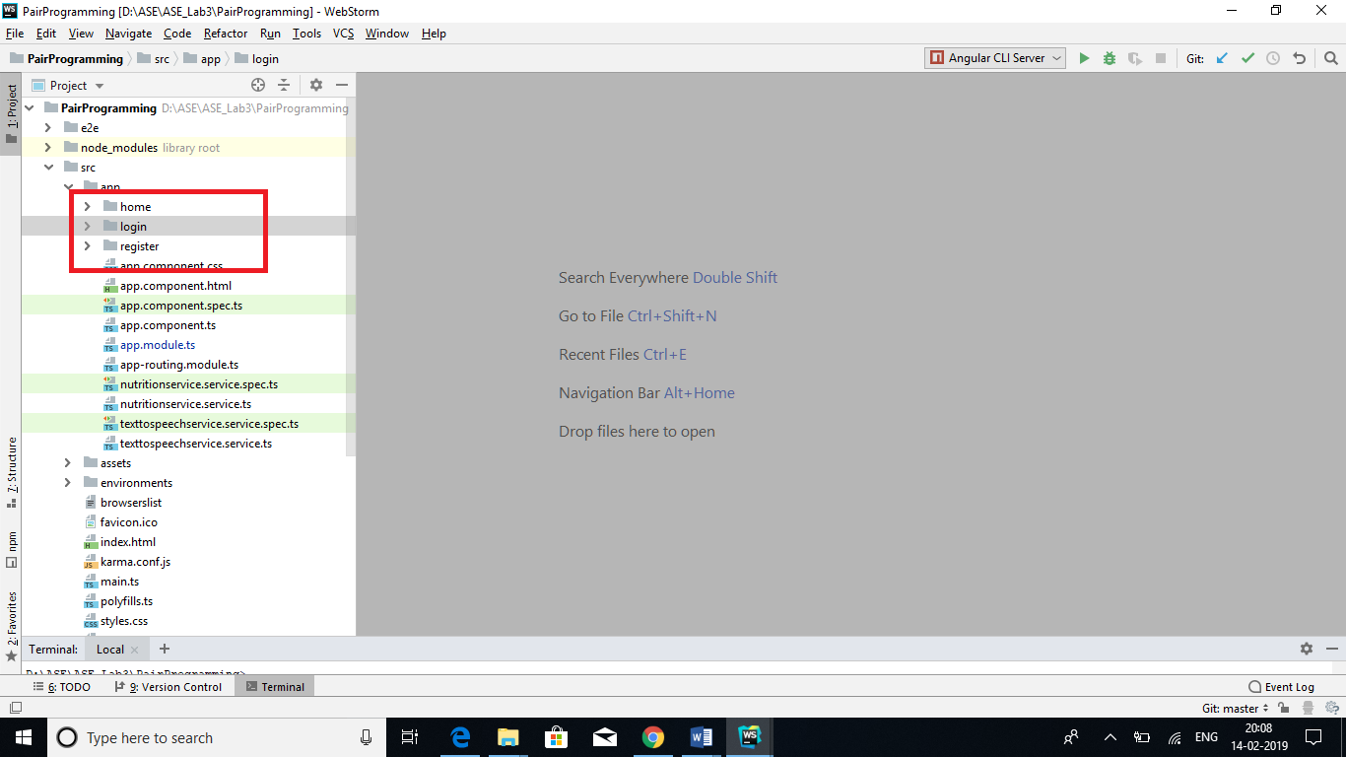

**Step-3:** Along with components we have also created services i.e; Nutritionservice and texttospeechservice

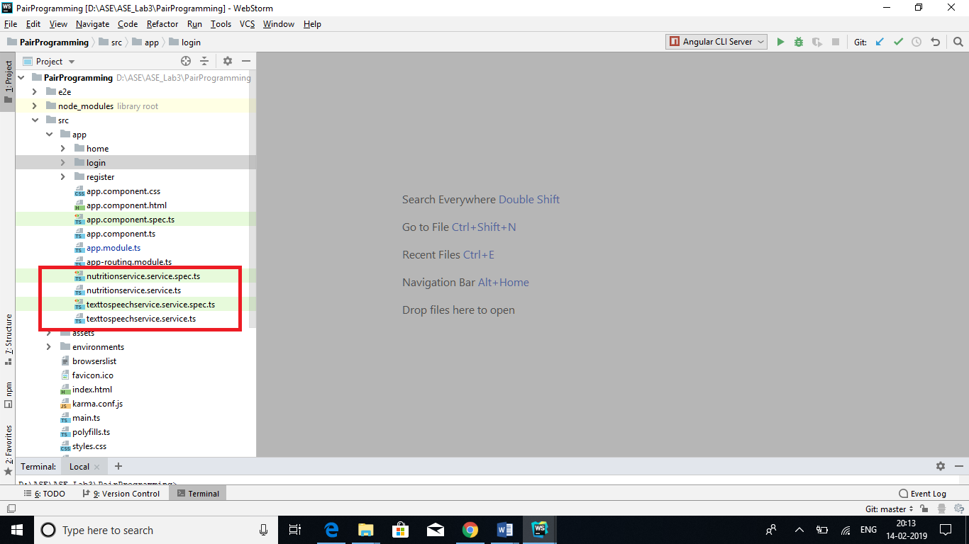

**Step-4:** Using HTML5 element “localStorage” we are fetching data of the form and storing locally

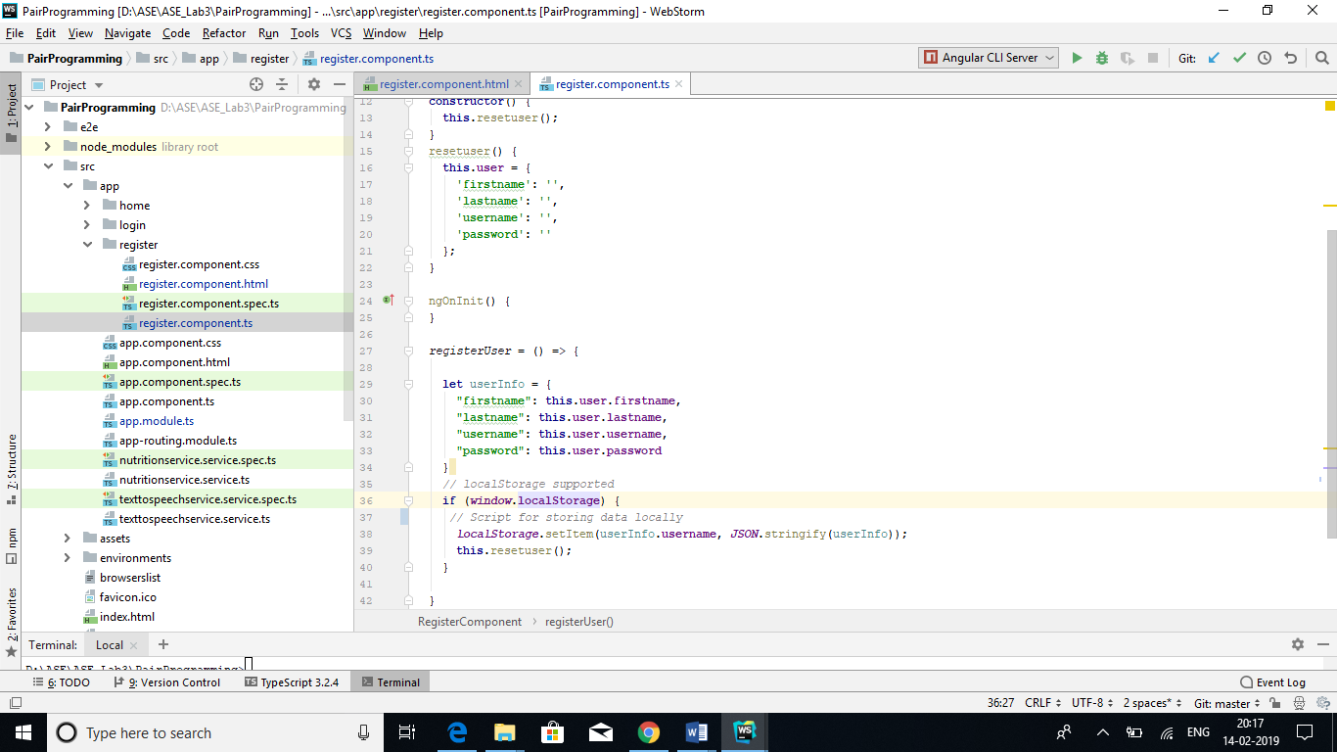

**Step-5**: Once user try to login we are fetching details from localStorage validating and allowing user to login if the credentials are correct

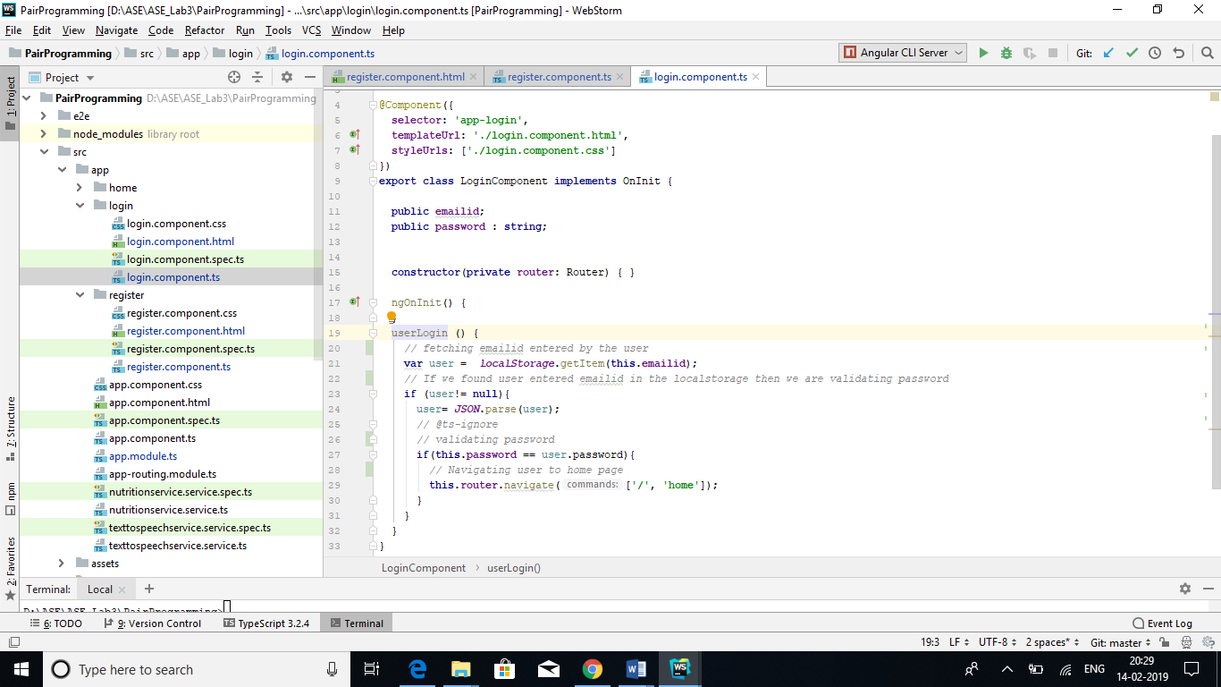

**Step-6:** Later we integrated with Nutritionix service and fetched the data required. In order to use this service we should register to Nutritionix development version and get the “Appid” and “AppKey”

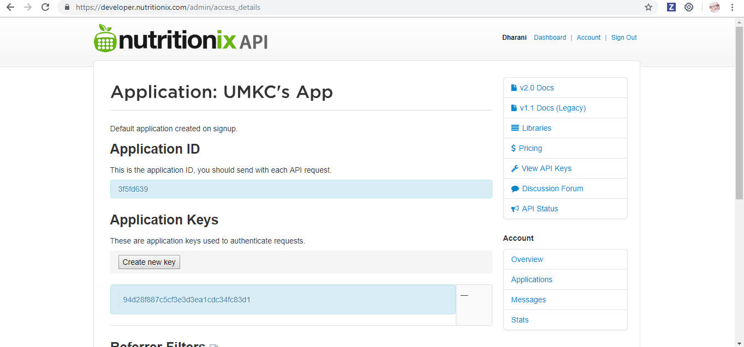

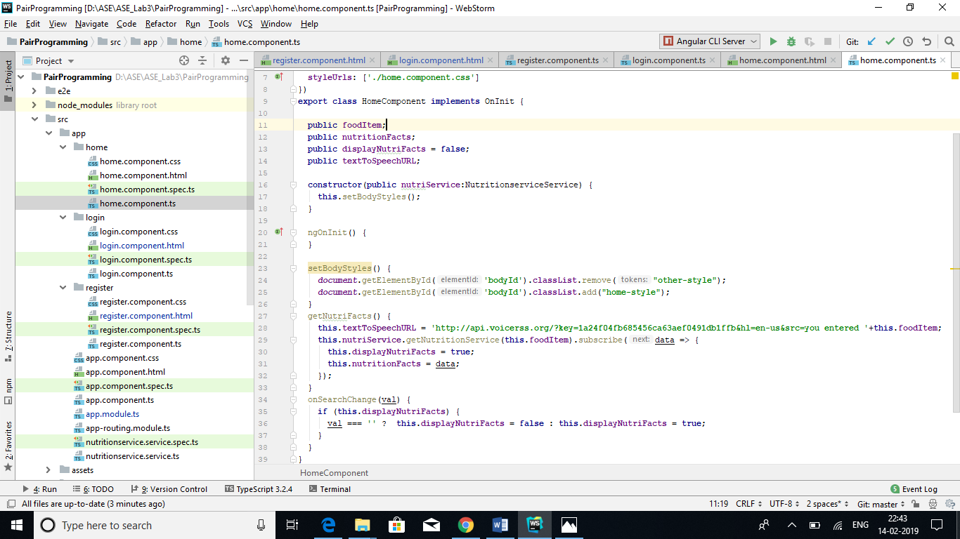

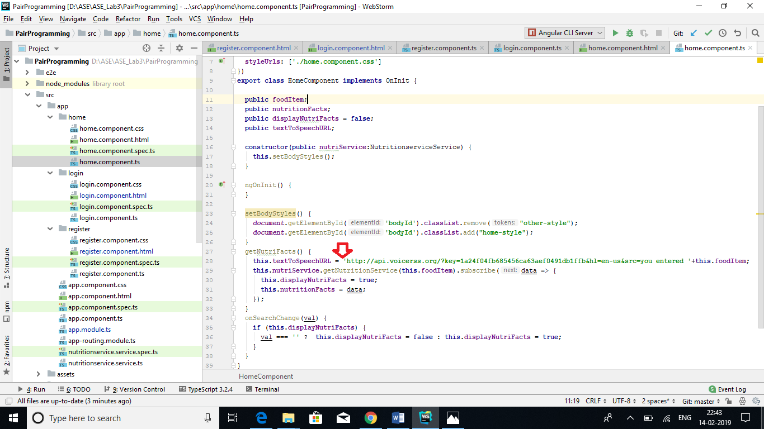Step-7: We have done the same with text to speech service and made our application speak according to what user entered on the home screen.

Input/Output:

Registration Page:

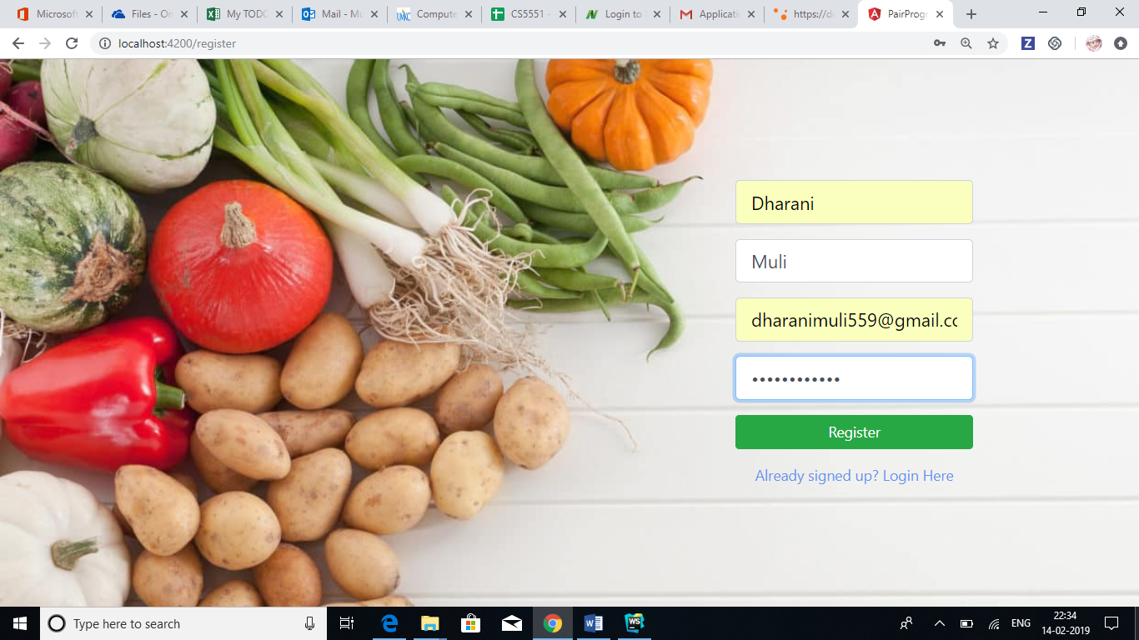**Input:** User registers by entering required details

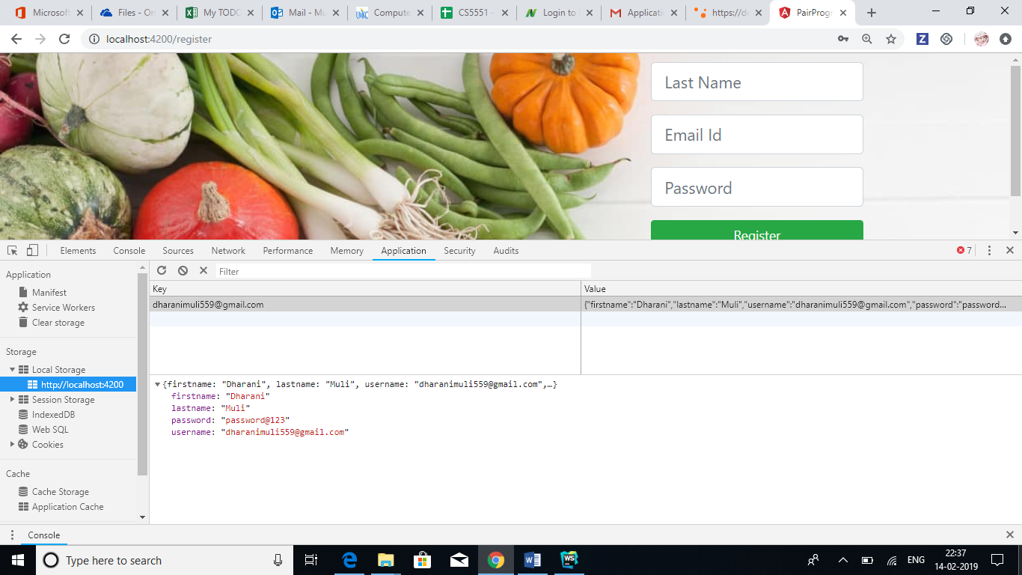**Output**: We stored all the details locally

Login page

Input: User entered login credentials. 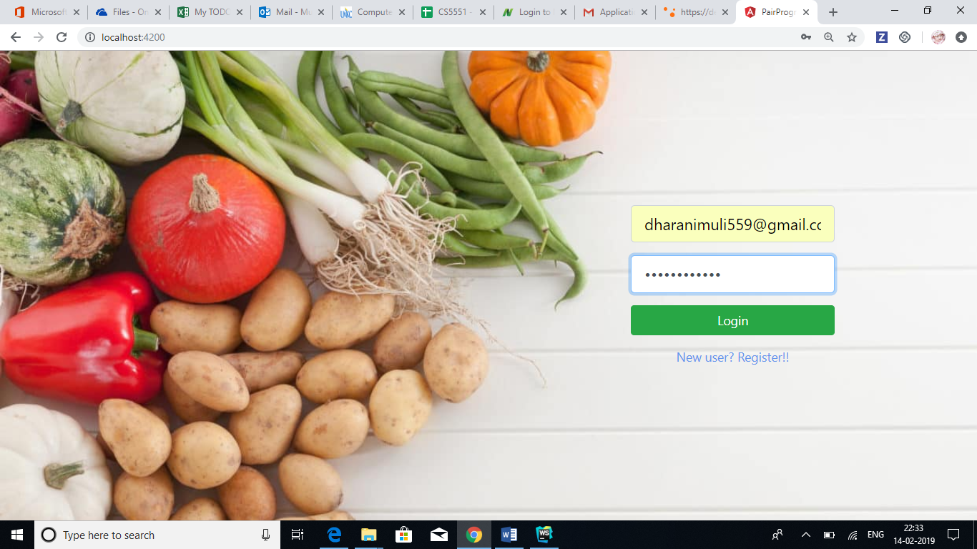

Output: If she is a valid user then we are navigating to Home page

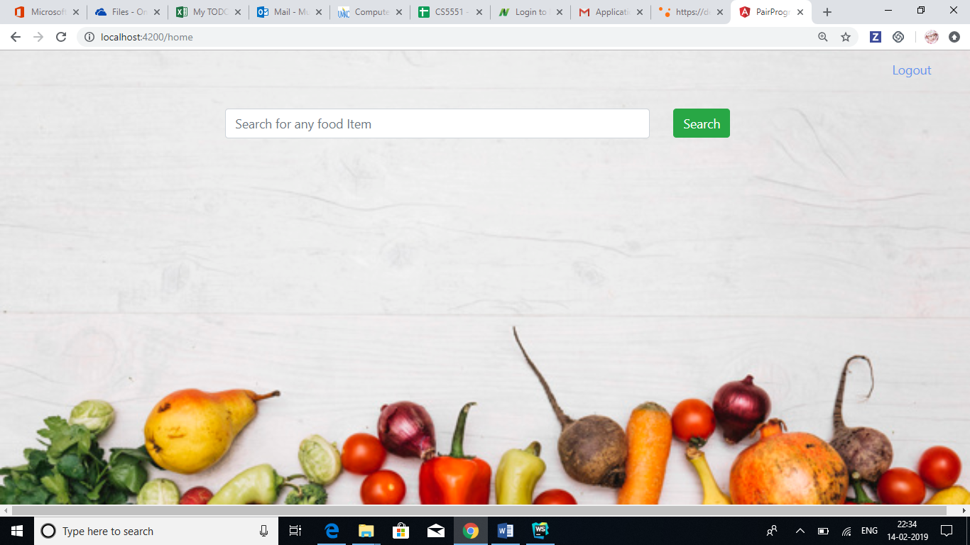

Input: If non-registered used tries to login then we are throwing an error

Output: Throws an error

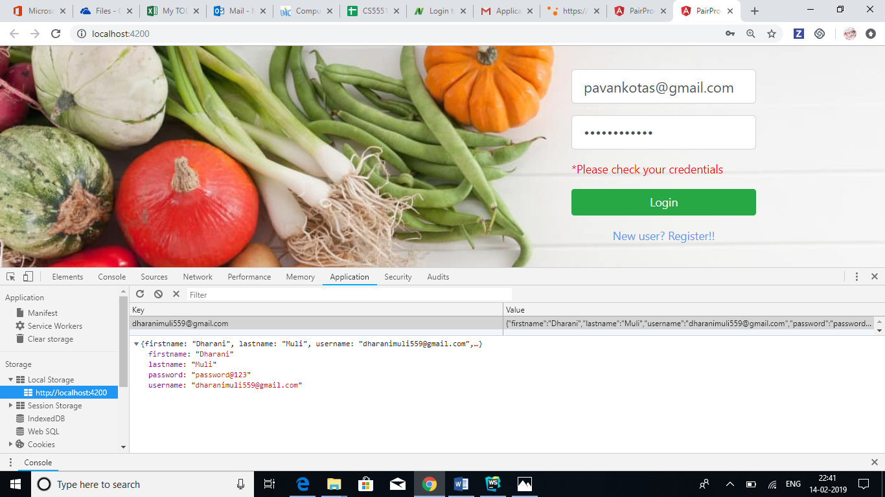

Home Page

Input: User searches for food item

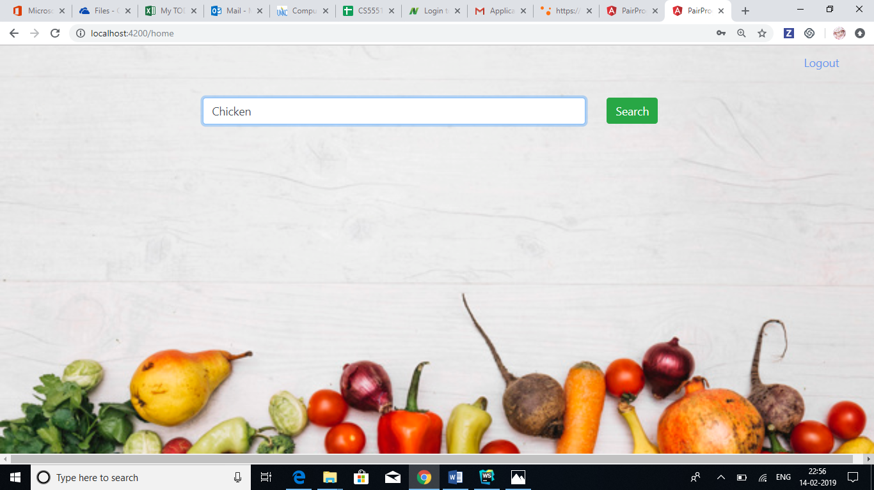

Output: Displaying Calories and Weight information of that particular food item. Moreover, text to speech api will speakout the searched item.

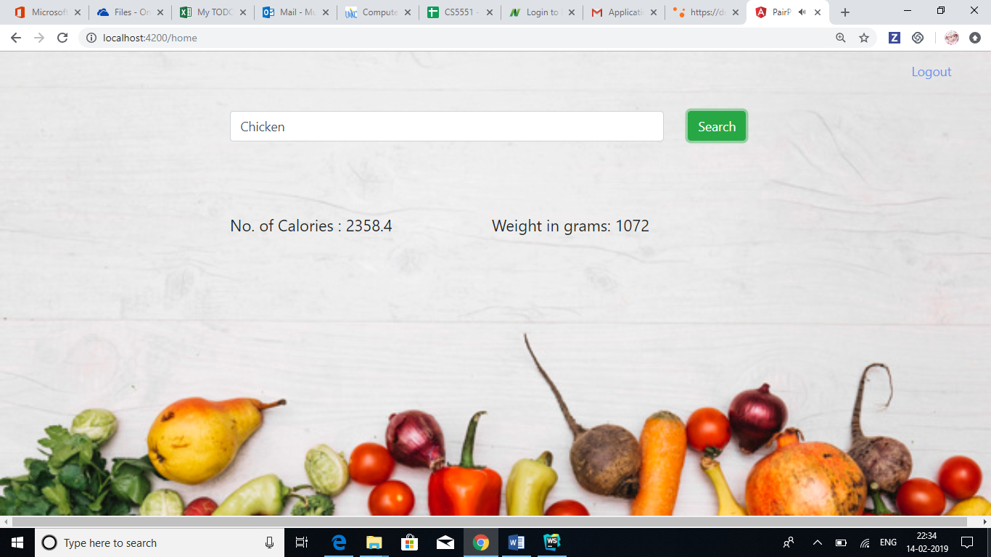

Issues/Limitations:

IBM doesn’t provide API keys so we chose different API.

Conclusion:

This Lab assignment helped us getting hands on experience on Angular 7 and localStorage concepts. Apart from that we learned how to integrate with services on the UI side doing UI mashup.